Putchar Error :
- warning: character constant too long for its type -----> putchar('tabuada realizada');
- warning: passing argument 1 of ‘putchar’ makes integer from pointer without a cast [enabled by default]
/usr/include/stdio.h:586:12: note: expected ‘int’ but argument is o
- In function ‘main’:
p04e04b.c:23:11: warning: multi-character character constant [-Wmultichar]
p04e04b.c:23:3: error: too many arguments to function ‘putchar’ ----> putchar('%d',&n);
- warning: passing argument 1 of ‘putchar’ makes integer from pointer without a cast [enabled by default]
/usr/include/stdio.h:586:12: note: expected ‘int’ but argument is of type ‘char *’
p04e04b.c:23:3: error: too many arguments to function ‘putchar’ ----> putchar("%d",&n);XAXA

- A soma de 0 será 210 enquanto o produto é -2102132736 , por a variável produto a long.
- Warning da função main do l.do luis damas: warning: return type defaults to ‘int’ [-Wreturn-type]

c04p09.c:8:9: warning: implicit declaration of function ‘toupper’ [-Wimplicit-function-declaration]

soma += i;
2.
error: expected declaration specifiers or ‘...’ before string constant

dia 24/07/2014
estágio na UTAD:
codigo_de_verificacao.c:5:2: error: variable-sized object may not be initialized
programa: codigo_verificacao em Documents/estagioUTAD
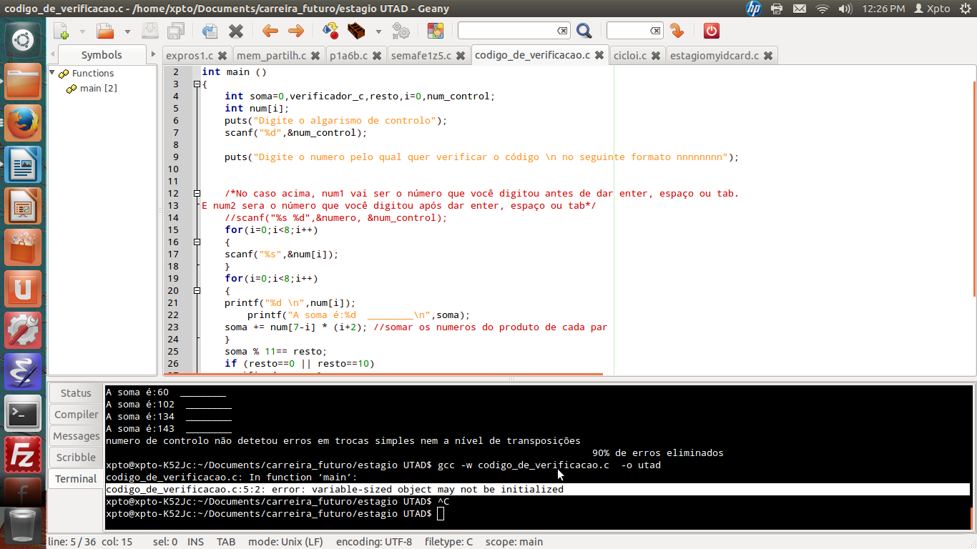
legenda:forscanfeprintf

dúvida para o Portugal a Programar:
e link:http://www.portugal-a-programar.pt/index.php?app=forums&module=post&section=post&do=new_post&f=59
+++++++++declaração de variáveis++++++++++++++++++++
[CODE]
#include <stdio.h>
int main (void)
{
for (int j=5;j;j=j-1)
// to compile doing this declaration inside on (flux control) for
//gcc -std=c99 foo.c -o foo
int i=0;//i;
{
while(i<=10)
{
printf("%d * %3d = %3.5d\n",j,i,j*i);
i=1+i;
}
puts("");
[/CODE]
xpto@xpto-K52Jc:~/Documents/ip$ gcc -std=gnu99 t06c04.c -o t06c04
t06c04.c: In function ‘main’:
t06c04.c:15:3: error: expected expression before ‘int’
t06c04.c:17:10: error: ‘i’ undeclared (first use in this function)
t06c04.c:17:10: note: each undeclared identifier is reported only once for each function it appears in
t06c04.c:19:33: error: ‘j’ undeclared (first use in this function)
xpto@xpto-K52Jc:~/Documents/ip$ gcc -std=gnu99 t06c04.c -o t06c04

text: for doodle No âmbito do curso de Verão: Porto Releaved.
O workgroup de atividades sociais planeou fazer visitas a estes sítios, logo pretende-mos também saber que de nós também que participar nas visitas :)

sim fomos, e anos antes tinha-mos estado os 3 na mesma turma da natação :)

sim fomos, e anos antes tinha-mos estado os 3 na mesma turma da natação :)

